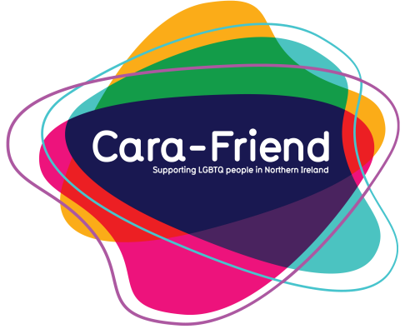
And supported by:
In partnership with:
Gay Straight Alliance
Guidelines Toolkit
INTRODUCTION

All schools have a duty of care for their pupils. This includes looking after their physical safety and mental health, as well as their personal development. Often schools can be a difficult environment for LGBTQ+ young people, and this can affect their wellbeing. A Gay Straight Alliance (GSA) is a great way to counteract this; allowing pupils, from all walks of life, to come together to promote acceptance of and support for LGBTQ+ students within the school community.
Still Shouting, a research study undertaken in 2016, showed that 86% of young LGBTQ+ people are aware of their sexual orientation and/or gender identity at school, and that 68% of them were bullied in school because of this. This highlights the importance of inclusion of LGBTQ+ young people in our schools, making them feel safe, accepted, and valued.
Gay Straight Alliances are not just for LGBTQ+ students, they are also a great way for straight allies to get involved. Though the theme of the GSA is LGBTQ+ inclusion, it is a great way for all involved to learn new skills, increase awareness, gain public speaking, improve confidence and meeting management experience; all while increasing their future employability. As well as being inclusive for all sexual identities and gender orientations, GSAs should cater for all ages and year groups. It works best when the group is having fun while also being active in their school community to help tackle bullying, homophobic and transphobic language, and exclusion.
GSAs should be peer-led groups, meaning that the students themselves will be running the group with little supervision needed from school staff. It is recommended that one teacher is involved in assisting the students to set up the GSA (a sponsor), and even to help them organise over the first year. The teacher/sponsor will help nurture the students involved in the GSA and to help grow their organisational skills, as well as acting as a champion for the group at staff level. The teacher should share an interest in the protection of both LGBT and non-LGBT students, as well as raising tolerance and acceptance of different identities.

“I knew from the very beginning that GSA would be a safe place for people to be themselves and hang out without fear of homophobia, transphobia and any other forms of bullying. I, along with others, wanted to inform peers of the damage they can cause from bullying, and to encourage everyone to look toward a future with equal rights for everyone! GSA for me and many others, added to the one I already had, and I know it gave others the encouragement to be able to come out and express themselves, I am so happy with the achievements we have made and the progress of this amazing and inspiring group, and I hope that in the future other schools and places of education can take our example and have a group like this to help towards a brighter future for all!” – Wynter, Student
SETTING UP
A group can be set up in two ways. Either a teacher leads the setup and invites students to become involved who then take over the running of the group, or students take the initiative themselves and seek support from a teacher to help the group get set up and grow. From there, the students and teacher(s) can work on their group proposal to be shared with the school principal and if required, the Board of Governors to gain permission and support for this type of group to be set up.
This document can be presented along with the group or students’ own plan for setting the GSA up. This means, in addition to this guide, the students should look to have compiled their school-specific details for where the GSA will be held, when it will take place, how it will be managed and how many pupils share an interest in this group. Statistics can be used to show that a group like this is important and is relevant to students within the school e.g. estimates for the number of LGBTQ+ people in the UK population range from 6-10%. If your school has 500 students, 30-50 could potentially be LGBTQ+ ranging from ages 11 to 18.

CONSIDERATIONS
When setting up a GSA group it is important to plan well in advance what the aims of the group are and how activities will be managed. The group might get concerns from teaching staff around the management of the group and time commitment it will involve. To ensure this is thought through, consult with the support staff member/sponsor.
Some parents might not be clear on the need for a group like this so therefore it is important to share as much information with them as possible. The group ideally will factor in outside perceptions and provide a safe space of understanding and respect.
The Board of Governors may want to understand the expected outcomes and costs of any potential group setup, so preparation is the key!

TIPS
Below are some tips to bear in mind to help get a group started and to give the group structure and focus:
• The group could run during one or two lunch times a week, or after school when the majority of people interested should be free.
• It should take place somewhere relaxing – ideally not a classroom – somewhere like a common room is ideal.
• Anonymity should be considered a protected right of all of those involved in the group, it is important that the focus of the alliance is clear and that their sexuality and gender do not need to be shared, this means that when someone is known to be attending the group, it doesn’t necessarily mean they are LGBTQ+.
• It should be fun! A sense of support should be maintained by having a good mixture of workshops, speakers and fun activities. Fundraising activities can be part of this within the school.
• Before the group starts meeting, a clear structure should be in place. There should be one or two leaders (or chairperson) of the group, and others highlighted for support roles including social media and administration.
• The group, as a collective, could consider nominating some LGBTQ+ students who would be comfortable as public-facing (within school) representatives of the group, who will have knowledge on LGBTQ+ issues to help/support anyone with questions.
• There should be some focus for the group to organise diversity and inclusion awareness events. These could include Anti-Bullying Week, which is usually held in November; International Day against Homophobia and Transphobia, which is usually held in May; and LGBT Awareness Week, which is also in May.

It is important to note that there may be some opposition to setting up a group like this, so it is really important to outline and reiterate that the group is there to support pupils’ mental health, well-being and personal development; it plans to challenge bullying in general, not just homophobic and transphobic bullying. A further benefit of having a staff sponsor, is that this can help tackle any opposition to the group and highlight the role of champion.

“Before joining our GSA group, I was shy about who I was, but I felt immediately welcomed. It gave me confidence to speak out loud and voice my own opinion. The group has been one of the best things that has ever happened to me. I hope other schools will be able to experience the same thing I have in their GSA.” – Natasha, Student
CASE STUDY
Currently there are few schools in Northern Ireland with GSAs. One of the first schools to set up a GSA was Hazelwood Integrated College in Newtownabbey. A pupil approached one of the teachers and asked them to support their request to set up a group which would look to improve the inclusion of LGBTQ+ students. They called their group ‘Gay, Straight, Whatever!’ or GSW. This is how they setup and run their group:
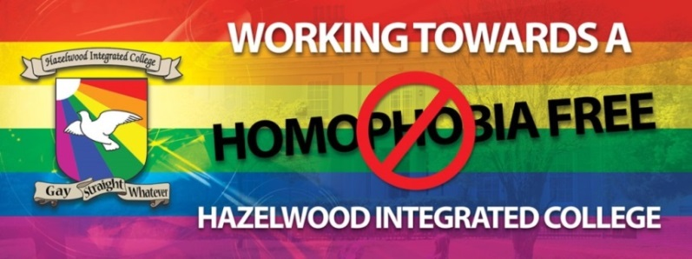
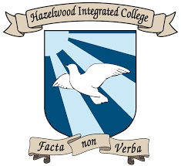

- The group was set up in 2013 following a meeting of expression, where other students were able to support the decision to proceed. During the first year the emphasis was on building membership, and promoting visibility of the LGBTQ+ community within the school. Within their first year they also attended their very first Pride event in Belfast.
- There are student leaders in place who run the group, they are helped and supported by a teacher who helped to start the group; she acts as the GSW champion within the school staff members. Elections are held at the end of the year to elect new positions. All of the members involved are allowed to vote for who they want to run the group.
- They meet every Thursday after school from 3:30pm until 4:30pm (when the last school bus leaves).
- They meet inside the schools youth team room, which is large enough for group activities and where there are sofas with tea/coffee facilities available.
- They hold activities, including workshops and training, presentations to assembly, and some events/activities that are just for fun too, meaning that they have a friendly environment that makes it fun for people to be involved in.
- They were involved in the successful campaign within the school to have a gender-neutral uniform policy, and also to provide for a gender-neutral bathroom, in order to support transgender pupils. They also held an assembly where a transgender member spoke to the entire school about their own experiences.
- As well as attending the Pride event in Belfast, the group also attended a vigil for the victims of the Orlando shooting, took part in a day of silence in support of IDAHOT, attended their GSW Christmas dinner, raised money for Carafriend Youth and welcomed some visitors to their group including: Equality Commission, Relate NI, Rev. Chris Hudson and SAIL NI.
RUNNING THE GROUP
It is important that the group is run fairly, openly and democratically. This gives the members of the alliance a feeling of inclusivity as they will have a say on how the group will be run. They could vote on what has been presented to the group, so that there is buy-in from everyone involved.
The following suggested positions are there to coordinate the group’s work and to manage its resources, as well as giving the members of the GSA experience in organising and managing a group:

- Group Leaders: They are responsible for the efficient running of the group, and to help ensure the cooperation of all members. They would be responsible for organising meetings and overseeing the promotion of the group within the school. They can also take initiative to present ideas to the group about events to run or guest speakers to invite in.
- Administrator: The admin role will be responsible for keeping a line of communication between the leaders, the wider student body and the teacher(s) who are responsible for the group. (They could also be responsible for managing the group’s social media page and keeping a track of the current goals/events that the group are taking a part in). A Facebook group (closed/private) can allow the group members to stay in touch and communicate with each other when planning and organising events.
- Other roles could include Social Media Administrator, Year Representative or Designer/Creative Administrator. These are ultimately at the discretion of the group and which roles they believe will be necessary.

The group should have a formal structure to ensure responsibility can be taken for each activity; however it should be kept informal at meetings to ensure inclusion. Members who simply want to come to the meetings and/or get involved in events or workshops should be encouraged, to broaden the peer base of the group and to increase the impact the GSA has on the school generally.

RECOMMENDATIONS
Below are a few recommendations that can help get the group thinking about what types of activities they want to take part in. Collectively the group can decide on these and take responsibility for each part of the organisation of it, or the teacher(s) in charge can make some suggestions to the group.

Taking part in a Pride Parade: This allows the group to experience being part of the wider LGBTQ+ community, and help the group create relationships with other members outside the school too. There are three Prides in Northern Ireland at present: Belfast Pride, Foyle Pride and Pride in Newry. This can be viewed very positively from the overall school perspective; to be involved in an event like this demonstrates the schools inclusivity. | Training for Teachers: This will give the group a chance to relay to staff a pupil’s experience on how transphobia and homophobia can affect them. It will also give the staff training on LGBTQ+ awareness. Training can be organised by the group themselves, someone could be invited to deliver relevant training, or ask another organisation to assist them in developing a training presentation, such as Cara-Friend and Shout Out.
LGBTQ+ Role Models: This allows members to be role models or mentors for other students in the school, who might be less comfortable about their sexual orientation and/or gender identity. The LGBT role models should be evenly spread out between the different year groups to allow all fellow students to approach them with any queries or to seek peer-led advice. | Days Out: Arranging day-out events to other schools and LGBTQ+ organisations or celebration dinners at special times of the year. Attendance at LGBT-related events outside the school allows the group to bond, as well as to experience engagement with other groups and communities. Inviting other schools in or visiting them at their premises can be useful activities to improve relations and also share the message of inclusion and diversity.
Assembly Presentations: The group can offer presentations for members to present during the different year group assemblies on raising LGBTQ+ awareness. This provides for a peer-led approach to tackling homophobic and transphobic bullying and language. | Social Media Presence: A Facebook page or similar could be set up to allow for the group to access any information that was discussed previously during the meetings. It is also useful for members or other students to access information relating to signposting to other organisations.
Why I’m an Ally: This is a project that ally members of the group can carry out, in order to raise awareness of the group among non-LGBT students, or to communicate why they feel strongly about LGBTQ+ inclusion amongst their peers. | Increase Visibility: Increasing visibility in schools is important and can be as simple as organising events for LGBT Awareness Week, or putting up a poster stating the school is a LGBTQ+ safe space, or using the rainbow flag. It is hoped that visibility will strengthen the sense of inclusion.

“As a new member of staff, I have been overwhelmed by the support and camaraderie shared between staff and students in the GSA. This group is a truly phenomenal example of how schools can support students in all aspects of their personal, emotional and academic development and ensure that staff feel comfortable in their working environment. The respect and acceptance at the heart of GSA radiates messages of positivity and equality and makes our school truly progressive, pioneering the path towards a more inclusive future.” – Stacey, Teacher

CONCLUSION

A Gay Straight Alliance could be a great addition to any school. The opportunities for both the school and the student body are numerous. It helps demonstrate that the environment is a safe one where bullying and discrimination are not tolerated. It is adaptable in its setup and can be sustained for as long as the students feel it is necessary in the school to achieve their goals. It can also encompass other minority groups within the school who are non-LGBT e.g. inclusion of ableism and racism.
Schools that support GSAs and encourage their setup and development help to end the stigma faced by LGBTQ+ students, and help to combat homophobic and transphobic bullying and language. They also provide an additional opportunity for their pupils to engage in a learning experience, which will ultimately help with their personal development. They can be a great addition to any school and as well as promoting inclusion and offering support, they can act as a great network for peers in the education community.
If you would like to set up a Gay Straight Alliance in your school, and feel like you would benefit from some organisational support, please contact the youth team in Cara-Friend on admin@cara-friend.org.uk.

CONTACTS
Cara-Friend LGBT Youth
Cara-Friend runs the LGBT youth service for Northern Ireland, and is based in Belfast. It also runs regional youth groups across NI. Cara-Friend offers one-to-one support for young people with professional youth workers, as well as safe space youth groups for those identifying as LGBTQ+. Cara-Friend also provides support, training and education opportunities to schools who wish to avail of workshops for staff or students, or simply need advice on a particular issue.
www.cara-friend.org.uk
www.facebook.com/cara-friend
GenderJam
GenderJam is a social meet up and support organisation for anyone who identifies as transgender, non-binary or gender fluid. It holds regular meet ups for people aged up to 25 in Belfast and Newry. GenderJam also provides training and advice for schools, and support on a one-to-one basis for young people.
www.genderjam.org.uk
www.facebook.com/genderjamni
Sail Northern Ireland
SAIL have been working in schools right across Northern Ireland for several years to improve the experiences of trans and non-binary young people. They can help parents, pupils, schools and other educational organisations to make the best decisions to help support their trans young people, as well as make those schools and organisations better places for the trans young people of the future.
www.sailni.com/backtoschool

Allen & Overy LLP
One Bishops Square, London E1 6AD United Kingdom | Tel +44 (0)20 3088 0000 | Fax +44 (0)20 3088 0088 | www.allenovery.com
In this document, Allen & Overy means Allen & Overy LLP and/or its affiliated undertakings. The term partner is used to refer to a member of Allen & Overy LLP or an employee or consultant with equivalent standing and qualifications or an individual with equivalent status in one of Allen & Overy LLP's affiliated undertakings.

