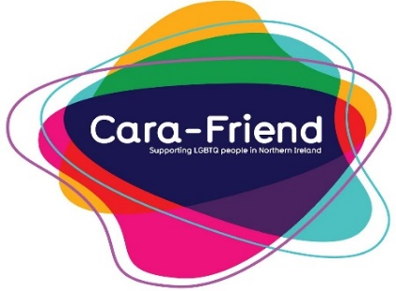

Application Form for Prospective Volunteers
This form is confidential
With this form you should receive information about Cara-Friend and the services we provide. Before becoming a volunteer - Please read our policies and procedures.
Return completed forms to: Tracy Crowe, Cara-Friend, 9-13 Waring Street, Belfast, BT1 2DX

Surname: __________________________
Given names: ________________________
Preferred name: _________________________

Address: ___________________________________ Postcode: _______________
Home number: _________________________ Mobile: _________________________
Email: ______________________________

Areas of volunteer opportunities within Cara-Friend which you would like to join:
(PLEASE CIRCLE THOSE APPROPRIATE)
LGBT Switchboard NI Fund Raising Web & IT Support Befriending Services

Administration Support Events Support Team Training

Gay Lesbian Youth Northern Ireland (GLYNI)

Other (Please specify) _________________________

If you choose to be a volunteer within Cara-Friend, we would like some indication of the amount of time to can commit to the team. (Please fill in the numbers and circle the time scale as appropriate)
__ Evenings per week / fortnight / month
__ Days per month / year
__ Weekends per month / year

What days would suit you best?
 | Monday | Tuesday | Wednesday | Thursday | Friday | Saturday | Sunday
Morning
Afternoon
Evening

Please give any information relevant to this application, e.g. previous experience, skills, qualities, why are you interested in joining, etc.
____________________________________________________________________________________________________________________________________________________________________________________________________________________________________________________________________________________________________________________________________________________________________________

As we are a charity organisation, it would help if you could let us know where you heard about Cara-Friend (Please circle as appropriate):

Friends/Family Work Education Cara-Friend Website

Other (Please Specify) _________________________

All applicants must meet with current Cara-Friend representatives for an informal selection process, be approved via Access NI checks and go through a training period before they will be considered verified Cara-Friend volunteers.
Please let us know which weekdays & time would be most convenient for you to attend the LGBT Centre for an informal interview:

Weekday: _______________ Time: __________

Date: ____/____/____

Volunteer Signature: ____________________ Staff signature: ____________________

